

November 21, 2023. Temp 39°, cloudy with rain. The leaves continue to swirl around just to annoy me.

This is the year that was. Here today, gone tomorrow! Donna and I will be celebrating our 21st anniversary in a few days. How time flies. I am a little early with the Lanza newsletter this year as we will be in Punta Cana in the Dominican Republic, with the grand kids, Melissa, and Ryan over the Christmas holiday.

Benjamin visited us in January for a planned trip to the Amherst model railroad show in Springfield, Mass. He & I had a great time checking everything out. While there, they were having a blizzard blowing in as we left.

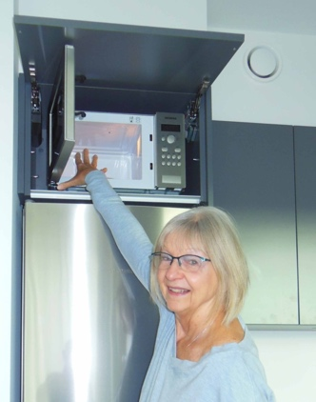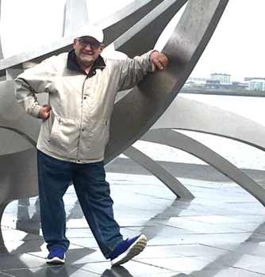 Starting way back in June, we found ourselves with the grand kids, Melissa, and Ryan again, only this time we were in Iceland! We had a great time discovering the villages, geysers, rivers and countryside. Other than the excursions, we walked everywhere. I enjoyed the many different museums, stores and restaurants. Donna walked the summer solstice midnight marathon, while the other family members ran it. She received her participation medal also! Rented an air B&B apartment which was nice, but the microwave on top of the refrigerator was “out of reach” for me!

Donna and I took advantage of the better weather at home using her swim spa she had waited so long to get last year.

I had a lot of fun rebuilding a South Bend lathe one our neighbors did not want as he was moving.

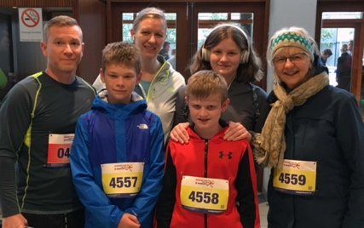

Benjamin, Robin and (Little) Ben visited us late summer, spent time catching up, visiting the Crawford Museum, and a couple of restaurants.

Donna has been very busy with her Shaklee associates, while volunteering with the elderly. We still deliver food for the church to those in need. We continue to learn French, which is a challenge.

We had a great get together at Bob & Carol’s with Gina, Kurt and Luke (from Florida): Matt (California): Bobby: and Charlie & Donna for the holiday season Sunday (11/19/23).

Memories: As kids, we were so happy when Thanksgiving came, it meant that Christmas was just around the corner and would be here in a few weeks. We wondered what we would get. Our parents would take us “downtown” where we looked in the store windows to see the toy displays in all its grandeur. I can remember O’Neil’s and Polsky’s in Akron. They were the best places to shop along with Glen’s Trains! We would get together with our friends and cousins to talk about the things we wanted and we looked in the catalogs that came in the mail from Sears, Montgomery Wards, Radio Shack.

During the season we were so busy, the time just flew by. Snowball fights, shoveling the snow, visiting the grandparents, aunts, and uncles. Lying on the floor watching our favorite TV shows or the bubble lights on the Christmas tree. It was awesome. We are looking forward to our Christmas vacation and the new year.

To you, our family, our friends, with love, respect and admiration, we wish you all a wonderful Christmas, and a Happy, Healthy, New Year! So. Until next year, we wish you and yours the best that life can offer.

Ben & Donna